REQUIREMENTS OF GOOD Decorative Design
Ornamentation added to enhance the basic design; the structure and the design can be separated without destroying the object involves the application of colour, line, texture, or pattern to an object.

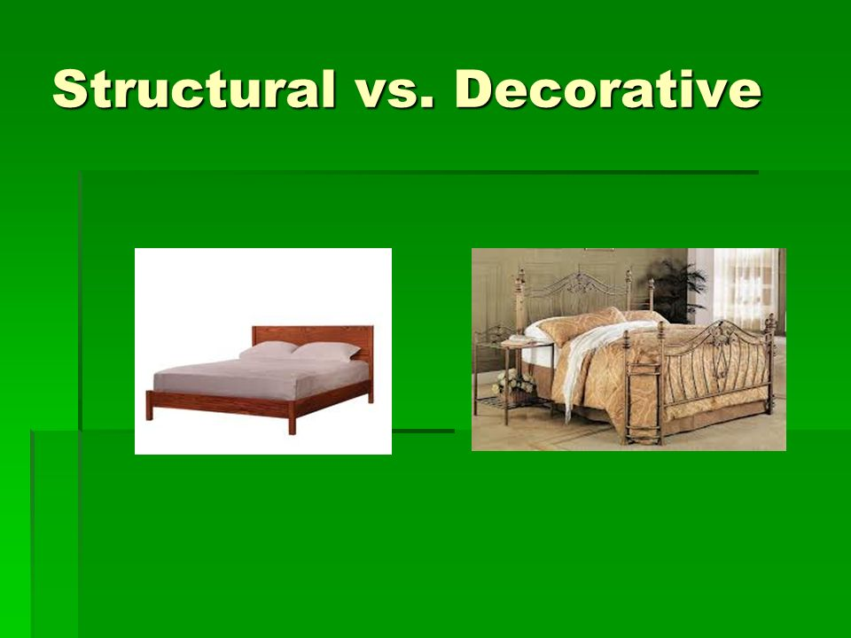

For Decorative design to be successful it must:
- Be suitable for the intended function
- Be appropriate for the materials that are being used. The decoration should be suitable for the materials and for the service it must give.
- Be appropriate in size and amount to the object in which it is found. The decoration should be used in moderation
- Be used to emphasize the structure. The spatial placement of decorative design should be at structural points and it should strengthen the shape of the object
- What is the purpose of the applied decorative design? There are number of purposes that decorative design can serve. It may record, educate and inform.
- Is the decorative design harmonious in design and idea.
- There should be enough background space to give an effect of simplicity and dignity to the design
- Surface patterns should cover the surface quietly
- The background shapes should be as carefully studied and as beautiful as the patterns placed against them
- If the design is expressing any time and culture, it should be utilized in a context that is compatible with and respectful of their origins

